- We impersonated one of our researchers account and uploaded in ‘My Data’ a fileset ‘The becoming of CHILL’

- This fileset contains 4 items, uploaded and visible in My data in the right order
The first item is a kind of ‘introduction’ to the other items. These next items are numbered N1, N2 and N3
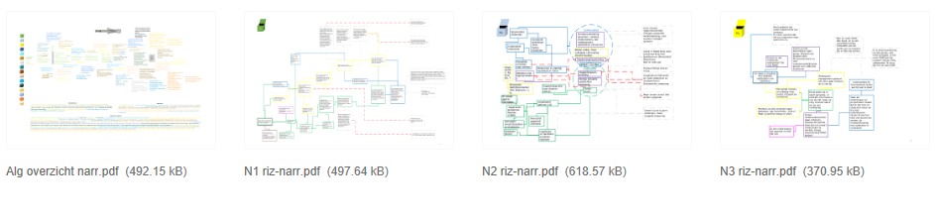
- Once published in Stage, the fileset is visible accompanied by a thumbnail of the third item in the fileset. However, our researcher prefers a thumbnail of the first item (=introduction) to be shown.
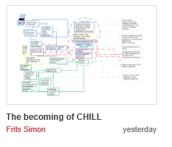
- We uploaded this fileset again (The becoming of CHILL_2) and tried to ‘influence’ the system’s choice of a thumbnail, but it seems to make a random choice. This time a different one (thumbnail of the second item in the fileset) becomes visible on the Zuyd Stage portal. 